Practical Exam   
Subject: WED201c  
Duration: 120 minutes

**Objectives:**

1. Using HTML to create the structure of the page

2. Create a Cascading Style Sheet (CSS) to format the page and then link it to the HTML file.

3. Javascript is used to validate a form and then link it to the HTML file.

**Background:**

In this practical exam, you are going to use some images and index.html page in the folder (**Resource/Images**) to finish the exam. You **don’t edit** any given image.

**Before styling index.html page**

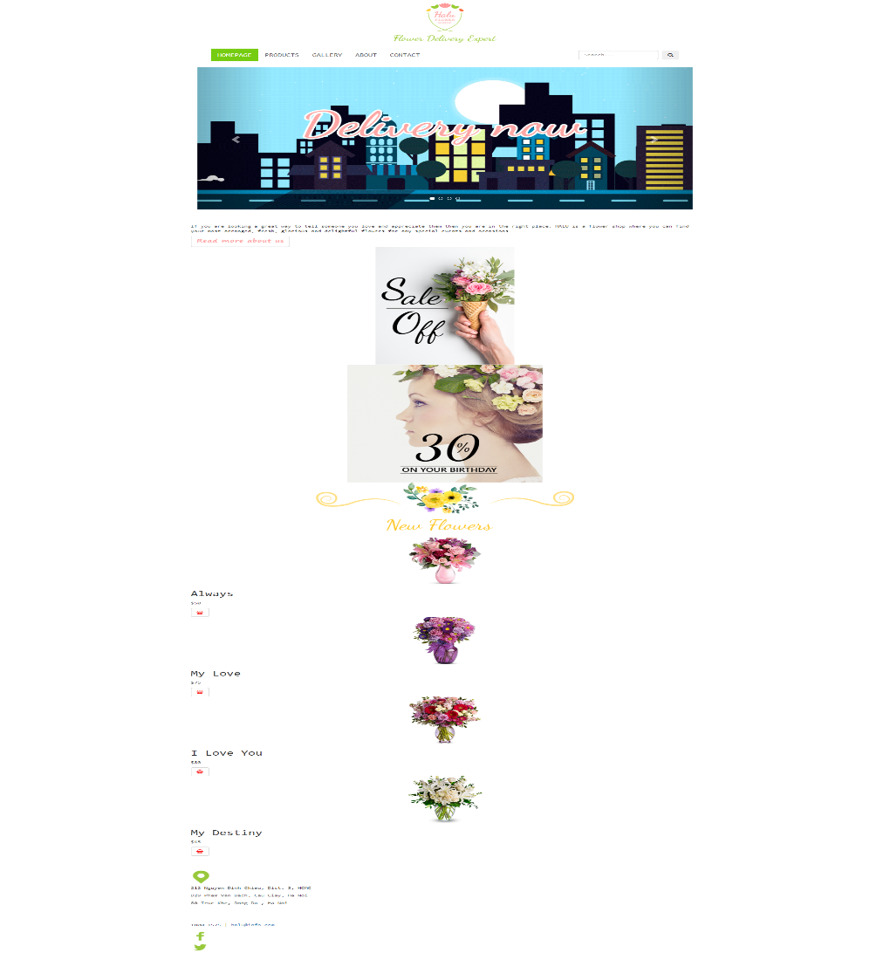

**The index.html page structure after adding html tags**

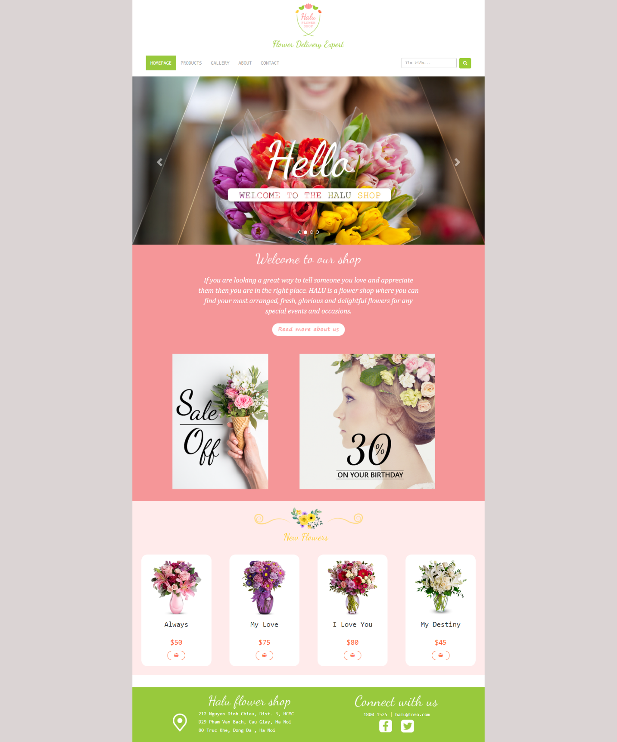

**The index.html page structure when users access by smartphone**

scroll



**Requirements:**

1. Create a file with the name **contact.html** and save it to **Resourse folder** as shown below:

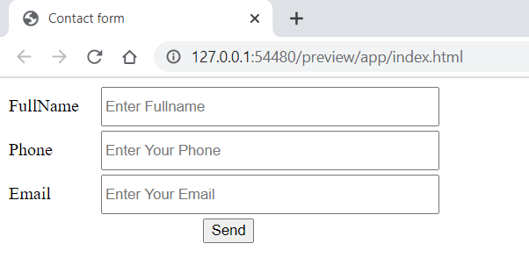

1. Create a file called **styleindex.css** to format the index.html page and save it to the **Resource folder**.
2. Create a file called **stylecontact.css** to format the contact.html page and save it to the **Resource folder**.
3. Create a file called “**mycode.js**” and save it to the **Resource folder.** You must link this file to the contact.html page.

In file mycode.js, you must **create function** base on description:

* The function checkForm(): This function is used to check the form when the user clicks on the button “Send”.

+ If the fullname is empty then a message “fullname is invalid” is displayed

+ If the phone is empty then a message “Phone is invalid” is displayed

+ If the Email is empty then a message “Email is invalid” is displayed

+ if both fullname and Phone are not empty then a message

“Welcome <<Fullname>> “-“ + <<Phone>>

We will respond to you as soon as possible”.

For example, the Fullname is “Nguyen Hoai Bao” and Phone is 0978654123 then a message

“Welcome Nguyen Hoai Bao - 0978654123,

We will respond to you as soon as possible”.

**Evaluation:**

1. **Add html tags [2 marks]**

* use tags div, label, input to create contact.html [1.5 points].
* Create a link for the contact menu to open the contact.html page [0.5 points].

1. **CSS [ 5 marks ]**

* Use Bootstrap's 12-column grid to present products [2 points].
* Use color, background, background-color,font-size… to format h2,p,a tags [1 points].
* Use border-radius and text-align to round button [1 points].
* Use css to format the content as shown above when the user accesses by smartphone [1 points].

1. **JavaScript [3 points]**

* Each condition in the function checkForm() runs correctly [0.5 points]. Total of this function is 1.5 points.
* Message display function gets 1 .5 points.

**Total: 10 points  
 (Students do not change the path of all files in the Resource folder)**

The End